Swakshadip Sarkar
Doctoral Candidate in sociology

Pronouns – They/Them | Wellington, New Zealand | +642108190317 | ssarkar9619@gmail.com | LinkedIn | Website

Career Objective
Enthusiastic and dedicated researcher seeking a research position where I can apply my expertise in gender studies, sociology, and migration studies to create impactful change.

Profile
- PhD Candidate at Te Herenga Waka - Victoria University of Wellington, School of Social and Cultural Studies. Thesis to be submitted on 1st December 2024 on access to legal and social institutions as well as support for transgender asylum seekers in New Zealand. A thesis abstract is included as Appendix 1.
- PhD supervised by Associate Professor Rhonda Shaw and Dr. Janepicha Cheva-Isarakul https://www.wgtn.ac.nz/sacs/about/staff/sociology-and-social-policy-staff.
- Three book chapters, two journal articles, one academic report, and nine blog articles published with seven forthcoming publications in international journals and books. Presented current and earlier research at 20 conferences and eight invited talks in different countries.
- Field-based research during PhD included multiple visits to Auckland, the most populous city in New Zealand. Secured research funding value of NZ$5400 from Victoria University of Wellington.
- During PhD, contributed to the School of Social and Cultural Studies and the School of English, Film, Theatre, Media and Communication, and Art History as a guest lecturer and tutor. Delivered a guest lecture in a Level 2 Sociology course. Tutored three Level 1 and Level 2 Sociology courses as well as a Level 1 Media course.
- Master’s degree included courses on migration, race, feminism, and Indian politics. The full academic transcript is included as Appendix 2.
- Pursued a postgraduate diploma in Psychological Guidance and Counselling which included modules on counselling and mental health disorders. The full transcript is included as Appendix 3.
- Have a good understanding of professional project management tools including most Microsoft Office programs such as Excel, PowerPoint, Outlook and Word.
- Have a thorough understanding of qualitative research tools such as NVivo and MaxQDA including applying them to data analysis.
- Have done a certificate course in teaching and TEFL/TESOL course which has given me significant knowledge on teaching strategies and techniques.
- Use interactive technology in my teaching. Created teaching materials such as formal presentations. Used different YouTube videos and Twitter post to analyse complex phenomena using sociological lenses. Used gaming platforms such as Kahoot! to create games further reinforcing learning
- Have taught research writing in different capacities in think tanks. This included training undergraduate and master's students to learn academic writing and other research-related practices.
- International focus in teaching and learning and in research collaborations. Have lived, studied and worked in three different countries. Speak and write fluently in English, Bengali and Hindi. Speak Spanish with limited fluency.
- Experience in collaborating with different organisations and working with different think tanks including contributing to research to inform policy decision-making.

Technical Skills
Area | Tools | Skill Level | Relevant Experience
Business Applications | MS Word, Outlook | Intermediate | Daily
 | Excel, PowerPoint  Zoom, Google Meet | Intermediate  Advanced | Work projects  Regular
Library | Google Scholar, Te Waharoa, ProQuest, Scopus | Advanced | Daily
Qualitative Analysis | NVivo | Advanced | Research projects
 | MaxQDA | Intermediate | Research projects
Artificial Intelligence Tools | ChatGPT  Scite.ai  Consensus.app  SciSummary | Intermediate  Intermediate  Intermediate  Intermediate | Research and teaching  Research projects  Research projects  Research projects
Interactive Gaming Platforms | Kahoot | Intermediate | Teaching

Education
PhD in Sociology December 2024 (Expected)
Te Herenga Waka – Victoria University of Wellington (QS Rank 2025: 244)
Dissertation Title: A Study into Barriers Faced by Transgender Asylum Seekers in Accessing Institutions and Support in Aotearoa New Zealand
Diploma in Psychological Guidance and Counselling (GPA 10.0) July 2024
Acharya Nagarjuna University
MSc in Social and Cultural Theory (Merit) December 2020
University of Bristol (QS Rank 2025: 54)

Relevant Training and Certifications
- Training for Tutors (Centre for Academic Development, Victoria University of Wellington)
- University Teaching (University of Hong Kong)
- 120 Hour TESOL/TEFL Certificate (World TESOL Academy, Accredited by Accreditat and The CPD Certification Service)
- Incarcerations: Are Prisons a Suitable Punishment? (University of Leeds)
- How Well Does International Human Rights Serve Marginalised People? (University of Kent)
- Human Rights, Ways of Life and the Future (University of Kent)

Research Experience
Doctoral Researcher November 2021 - Present
Te Herenga Waka - Victoria University of Wellington
- Performed a literature review on the barriers faced by transgender asylum seekers in accessing various institutions drawing from global research.
- Contacted multiple organisations to gather information and find participants for my research.
- Performed semi-structured interviews and conversations with transgender asylum seekers and people working in various organisations assisting transgender asylum seekers.
- Performed a case study on legal documents dealing with cases of transgender people seeking asylum in New Zealand.
- Applied for and secured ethics approval from the Human Ethics Committee.
- Applied for and secured grants to fund my data collection and conference attendances.

Research Advisor February 2023 - Present
Climate Xero (a think-tank working towards addressing climate change in South Asia)
- Assisted with day-to-day operations, working efficiently and productively with all team members.
- Advised the team on gender research especially around Hijra cultures and practices.
- Advised the team on research methodology, conducting qualitative research and disseminating research.
- Worked well in a team setting, providing support and guidance.
- Worked effectively in fast-paced environments.
- Used critical thinking to break down problems, evaluate solutions and make decisions.
- Exercised leadership capabilities by successfully motivating and inspiring others.
Research Advisor October 2021 – September 2022
Center for Regional Research and Sustainability Studies (a think tank working towards addressing violence and gender)
- Co-wrote a book chapter on sexual violence in Kashmir.
- Lead a project on digital experiences of transgender people in urban India.
- Supervised a group of ten interns, teaching them qualitative research and dissemination.
- Created spreadsheets using Microsoft Excel for daily, weekly and monthly reporting.
- Conducted research, gathered information from multiple sources and presented results.
- Created plans and communicated deadlines to complete projects on time.
- Developed team communications and information for meetings.
Gender Equity Researcher December 2021 – July 2022
Human Development Research Initiative (a think tank based at Sciences Po, Paris)
- Published a report on barriers for transgender people in seeking employment in India.
- Presented in a conference on international laws and policy recommendations on female genital mutilation (FGM).
- Worked on policy recommendation for queer asylum seekers in France.
- Learned new skills and applied them to daily tasks to improve efficiency and productivity.
- Exceeded goals through effective task prioritisation and great work ethic.
Research Intern August 2021 – April 2022
Centre for National Policy Research (a think tank working towards building inclusive policies in India)
- Gathered, arranged and corrected research data to create representative graphs and charts highlighting results for presentations.
- Assisted with preparing project-related reports, presentations and manuscripts.
- Prepared tables, graphs and fact sheets to summarise research results.
- Completed research, compiled data and assisted in timely reporting.
- Used critical thinking to break down problems, evaluate solutions and make decisions.
Research Analyst October 2020 – June 2021
University of Bristol
- Analysed course materials taught at the School of Sociology, Politics and International Studies to highlight the amount of content on race and ethnicity being taught.
- Gathered, arranged and corrected research data to create representative graphs and charts highlighting results for presentations.
- Interpreted data and made recommendations from findings.

Independent Researcher June 2020 – March 2021
Self-Employed
- Worked on a mixed method research project to analyse the barriers faced by women in entering academia in India.
- Sorted data into well-organised formats and transformed into figures.
- Determined areas of research to increase knowledge in particular field.
- Analysed and interpreted patterns and trends.
- Presented the research in a conference entitled "Gender Roles and their Impact in Academia" organised by European Molecular Biology Laboratory, European Molecular Biology Organisation, and Howard Hughes Medical Institute.

Teaching Experience
Guest Lecturer August 2024 – September 2024
Te Herenga Waka – Victoria University of Wellington
Lecture Delivered: Decolonial Sex/Gender Identities in course SACS202: Gender and Sexuality Studies: Key Thinkers and Concepts
- Delivered a specialised guest lecture on "Decolonial Sex/Gender Identities."
- Developed a comprehensive lecture plan, integrating key concepts of gender and sexuality studies.
- Engaged with the students and answered questions at regular intervals during the lecture.
- Contributed to the academic discourse on decolonial methodologies within gender studies.
Teaching Assistant June 2022 – Present
Te Herenga Waka – Victoria University of Wellington
Courses Taught:
- SOSC111: Sociology: Foundations and Concepts
- SOSC102: Doing Sociology
- MDIA104: Social and Interactive Media
- SACS202: Gender and Sexuality Studies: Key Thinkers and Concepts
Responsibilities:
- Supported classroom maintenance and upkeep, organising books and materials.
- Presented a wide range of information to students using hands-on instructional techniques for effective comprehension.
- Tutored students in small groups to reinforce learning concepts.
- Completed daily reports on attendance and disciplinary performance.
- Studied and implemented the latest information on specific subjects and learning strategies.
- Created lesson materials, visuals and digital presentations to supplement lesson plans.
- Delivered personalised educational, behavioural and emotional support to individual students to enable positive learning outcomes.
- Implemented practice exercises and group assignments to assist students in quick information grasping.
- Marked essays and assessments of the students and provided critical feedback.

Selected Publications
- Sarkar, S. (2024). Unveiling Marginalisation: Neuroqueer Experiences at the Intersection of Neurodivergence and Gender/Sexual Diversity in India. In K. Debnath and S. Chatterjee (eds.) Marginalised Groups in India: Historiography, Politics, and Policies (pp. 99-112). Routledge UK. https://doi.org/10.4324/9781003536611-9.
- Sarkar, S. (2024). Queer Liberation and Assimilation in India: Navigating Historical Contexts and Temporary Challenges. In F. H. Sarwar & B. Ganguly (Eds.), India & Identity: Some Reflections (pp. 182–193). Bluerose Publishers.
- Sahoo, S., & Sarkar, S. (2023). Gendered Dualism within Us! Understanding Gender Performances through Body Mind Dualism. In S. Kumar, N. K. Gautam, & M. Verma (Eds.), A Discourse on Transgender Society and Media Worldwide (pp. 24–34). Authorspress.
- Sarkar, S., & Sharma, A. (2022). Conflict, Sexual Violence, and the Culture of Impunity in Kashmir - Reminiscing The Past and Imagining The Future. International Journal of Current Humanities and Social Science Researches, 6(2), 35–43. http://www.indiancommunities.org/journal/index.php/ijchssr/article/view/188.
See a full list of publications at Appendix 4

Selected Conferences Attended
- Sarkar S. “Understanding Homosexual Identity in the Indian Context”, BASAS Annual Conference 2021, British Association for South Asian Studies, University of Edinburgh, Edinburgh, Scotland, United Kingdom, April 2021.
- Sarkar, S. "Navigating Positionality Working with Transgender Asylum Seekers in Aotearoa”, Global Challenges/Local Responses, Sociological Association of Aotearoa New Zealand, University of Waikato, Tauranga, New Zealand, November 2023 [Fully Funded].
- Sarkar, S. “Analysing Transgender Asylum Claims in Aotearoa Through Case Laws”, Global Challenges/Local Responses, Sociological Association of Aotearoa New Zealand, University of Waikato, Tauranga, New Zealand, November 2023 [Fully Funded].
- Sarkar, S. " Navigating Employment Challenges and Self-Advocacy: Experiences of Neuroqueer Individuals in India”, Anthropology in the Service of Nation, Indian Anthropology Congress, Indian National Confederation and Academy of Anthropologists & Indira Gandhi Rashtriya Manav Sangrahalaya (Ministry of Culture), Bhopal, Madhya Pradesh, India, February 2024.
- Sarkar, S. “Intersectionalising’ Transgender Studies: A Perspective of Transgender Asylum Seekers in New Zealand​”, 2nd Transgender Studies Conference, Northwestern University, Illinois, Chicago, United States of America, September 2024.
For a full list of conferences attended, see Appendix 5

Selected Invited Talks/Lectures
- "Transgender Theories and Decolonisation", delivered at Department of Sociology, Hindu College, University of Delhi, Delhi, India, June 2022.
- "Fallacies of the Indian Queer Movements", delivered at School of Social Sciences, University of Hyderabad, Hyderabad, Telangana, India, September 2022.
- "Marginalised Voices: Transgender Rights, Political Shifts and Intersectionality in India", delivered at the School of Social and Cultural Studies, Victoria University of Wellington, Wellington, New Zealand, May 2024.
For a full list, see Appendix 6

Honours and Awards
- Student Plenary Selection by the Sociological Association of Aotearoa New Zealand enabling the annual conference attendance at the University of Waikato, Tauranga. Awarded 2023.

Grants and Funding
- PhD Large Grant, Te Herenga Waka – Victoria University of Wellington, 8th March 2023.
- PhD Support Grant, Te Herenga Waka – Victoria University of Wellington, 23rd June 2024.

Professional Experience
Associate Editor May 2024 – Present
Deliberately Queer Journal (lodged with South Illinois University Carbondale Open Access)
- Perform blind peer review on the articles received and provide feedback to the author and editors
- Supporting the authors to edit their papers to streamline their arguments.
- Assisting the editors in pre-publication activities.

Secretary November 2019 – Present
Kontho (NGO working with children’s education and gender-based issues)
- Responded to emails and other correspondence to facilitate communication and enhance business processes.
- Updated spreadsheets and created presentations to support executives and boost team productivity.
- Recorded daily financial transactions using Quickbooks and handled payments of accounts.
- Drafted agendas, recorded minutes and generated documents to facilitate meetings.
- Recorded and tracked operational expenses to identify and eliminate wasteful spending.
- Created and updated records and files to maintain document compliance.
- Maintained daily report documents, memos and invoices
LGBTQ+ Subject Matter Expert July 2022 – December 2022
Stellar Instructional Design (providing awareness and training about gender and queer issues)
- Built partnerships with related organisations to develop support and gain greater attention for intersectional issues concerning LGBTQ+ lives.
- Offered friendly and efficient service to customers, handled challenging situations with ease.
- Produced course materials on different topics related to LGBTQ+ lives to help spread awareness among Virginia police officials.
- Worked on feedback from the coordinator and course attendees to grasp their unique needs.
Content Writer December 2021 – May 2022
WrittenlyHub (a content marketing start-up)
- Utilised exceptional writing, editing and proofreading skills to produce engaging and error-free content.
- Wrote and edited high-quality content and visually impactful programs under deadline pressure with exciting, captivating and authentic approach.
- Conducted interviews with subject matter experts to generate topics.
- Edited and proofread content to confirm proper grammar, quality and consistency with AP style.
- Provided writing support in fast-paced environment for variety of public-facing materials.
- Wrote advertising material for use by publication, broadcast or internet media to promote sale of goods and services.
Freelance Content Writer May 2021 – December 2021
Self-Employed
- Added keywords, meta descriptions and alt image tags to increase SEO presence.
- Created monthly Excel spreadsheets to manage client projects and deadlines.
- Used Microsoft Word, Google Docs and SharePoint to store and share created documents.
- Utilised exceptional writing, editing and proofreading skills to produce engaging and error-free content.
- Researched industry-related topics by performing interviews and combing online sources.
- Produced original, creative content for promotional advertisements and marketing materials.
- Wrote advertising material for use by publication, broadcast or internet media to promote sale of goods and services
Freelance Translator May 2017 – August 2019
ProZ.com
- Replicated flow, style and overall meaning of original texts.
- Reviewed news and current events in international publications, translating relevant information for leaders.
- Used translation software to verify complex terms and expedite communication process.
- Researched cultural etiquette and specific use of slang words.

Professional Memberships
- Sociological Association of Aotearoa New Zealand
- British Association for South Asian Studies
- Society for Research into Higher Education
- World Anthropological Union
- International Transgender Studies Association

Languages Spoken
- English (Fluent)
- Bengali (Native)
- Hindi (Fluent)
- Spanish (Basic Proficiency)

References
References Available upon Request

Appendix 1: Thesis Abstract
Dual Liminality and Violation of Rights: Transgender Asylum Seekers and Access to Institutions and Care in Aotearoa New Zealand
Abstract
Transgender people face criminalisation and persecution in many countries due to legislation and inequitable social norms. This predicament, which leads to experiential and institutional violence, has prompted some transgender people to seek refuge in nations reputed for upholding transgender rights. Aotearoa New Zealand is recognised internationally as a country supportive of transgender rights. While there is a body of literature that examines the challenges facing transgender people in accessing legal and social institutions in Aotearoa New Zealand, there is limited empirical research that focuses on the experiences of transgender asylum seekers. Within global literature, the focus has been on the legal adjudication process, with little exploration of their access to other legal and social institutions and support.
Addressing these gaps in literature, this qualitative study examines the experiences of asylum-seeking by transgender people in Aotearoa New Zealand, particularly in terms of institutional access and support. I conducted nine in-depth interviews with transgender asylum seekers and members of key non-governmental organisations, as well as a cross-case analysis of 12 legal cases related to asylum seeking. Theoretically, the study draws on aspects of critical race theory, queer theory, and questions around the social construction of illegality to understand a unique set of challenges that arise from the intersection between transgender asylum seeker participants’ gender identities and their immigration status. I employ the framework of dual liminality to illustrate how their complex identities lead to the experiences of uncertainty, marginalisation and precarity during and after the asylum-seeking process.
This research finds that, in contrast to international literature, transgender claims and evidence are less of a barrier during the asylum adjudication process. Instead, concerns regarding an applicant’s potential burden on healthcare, character assessments, and country-of-origin requirements may be more pivotal. A major issue reported by study participants is the lack of access to gender-concordant identification documents, which in turn severely affects their access to legal and social institutions during and after the asylum-seeking process. Due to their intersecting identities as transgender persons and asylum seekers, study findings show that participants experience gaps in policies, discrimination and a lack of awareness among service providers about transgender asylum seekers’ entitlements. Consequently, the support available to transgender asylum seekers in Aotearoa New Zealand may often be minimal and inconsistent, leading to their liminal gender and legal status to be perpetuated.
These findings illuminate the ways in which the international refugee frameworks, local policies and legal frameworks, as well as civil society collectively fail to sufficiently address the needs of transgender asylum seekers, thereby leading to the continuation of rights violations. As a result, this study recommends the introduction of policies and anti-discrimination legislation both at international and local stages to better ensure the rights of transgender asylum seekers in accessing the institutions and support they need. By doing so, Aotearoa New Zealand can legitimately claim its international reputation of being friendly towards transgender people and international refugee laws can effectively protect transgender asylum seekers.

Appendix 2: MSc Transcript
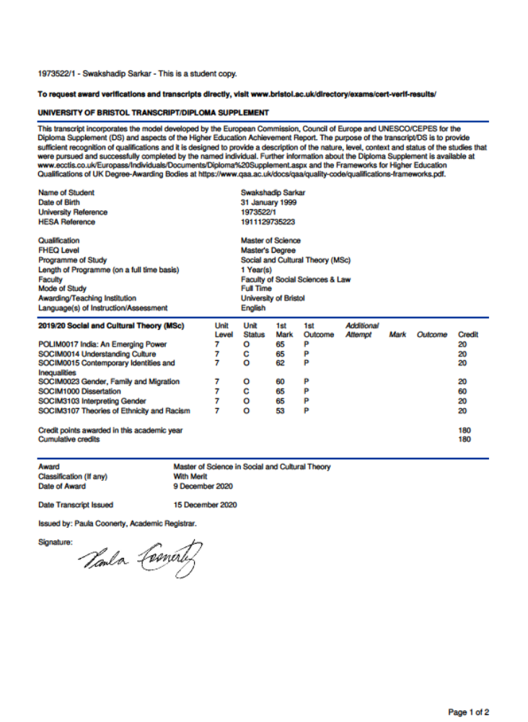
Appendix 3: Diploma Marksheet
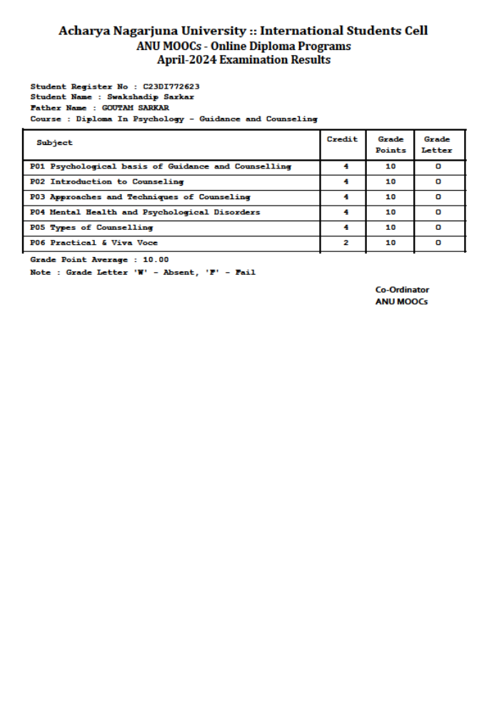
Appendix 4 – Full list of Publications
Book Chapters
- Sarkar, S. (2024). Unveiling Marginalisation: Neuroqueer Experiences at the Intersection of Neurodivergence and Gender/Sexual Diversity in India. In K. Debnath and S. Chatterjee (eds.) Marginalised Groups in India: Historiography, Politics, and Policies (pp. 99-112). Routledge UK. https://doi.org/10.4324/9781003536611-9.
- Sarkar, S. (2024). Queer Liberation and Assimilation in India: Navigating Historical Contexts and Temporary Challenges. In F. H. Sarwar & B. Ganguly (Eds.), India & Identity: Some Reflections (pp. 182–193). Bluerose Publishers.
- Sahoo, S., & Sarkar, S. (2023). Gendered Dualism within Us! Understanding Gender Performances through Body Mind Dualism. In S. Kumar, N. K. Gautam, & M. Verma (Eds.), A Discourse on Transgender Society and Media Worldwide (pp. 24–34). Authorspress.
Journal Articles
- Sarkar, S., & Sharma, A. (2022). Conflict, Sexual Violence, and the Culture of Impunity in Kashmir - Reminiscing The Past and Imagining The Future. International Journal of Current Humanities and Social Science Researches, 6(2), 35–43. http://www.indiancommunities.org/journal/index.php/ijchssr/article/view/188.
- Sarkar, S. (2020). DISSECTING UNIVERSALITY OF HOMOSEXUAL IDENTITY FORMATION FROM WEST BENGAL'S FRAME OF REFERENCE. SSRN Electronic Journal. https://doi.org/10.2139/ssrn.3794124.
Academic Reports
- Sarkar, S. (2022, May). Transgender People and Employment in The Era of Diversity and Inclusion (J. Yin, Ed.). Human Development Research Initiative. https://hdevri.com/2022/05/10/transgender-people-and-employmentin-the-era-of-diversity-and-inclusion/.
Public Scholarship
- Sarkar, S. (2022). Mental Health – A Significant Issue for LGBTQIAHK+ Population. Sonket.
- Sarkar, S. (2022, June 11). ‘They're Violent, Uncultured and Need Western Education' – Masculinity of Asylum Seekers and its(?) Impacts in the West. Refugee Watch Online Journal. https://refugeewatchonline.wordpress.com/2022/06/11/theyre-violent-unculturedand-need-western-education-masculinity-of-asylum-seekers-and-its-impacts-in-the-west/.
- Sarkar, S. (2022, June 11). Is Gender Binary? The Forgotten Gender Minorities. Doing Sociology. https://doingsociology.org/2022/06/10/isgender-binary-the-forgotten-gender-minorities-swakshadip-sarkar/.
- Sarkar, S. (2022, March 2). The War Over Hijab and Gendered Islamophobia. Doing Sociology. https://doingsociology.org/2022/03/02/thewar-over-hijab-and-gendered-islamophobia-swakshadip-sarkar/.
- Sarkar, S. (2022, February 17). Minority Mental Health and Workplace [Slides]. Slideshare. https://www.slideshare.net/SwakshadipSarkar/minority-mental-health-and-workplace.
- Sarkar, S. (2021). Fractures in Healthcare: Plight of Transgender People in India. Sonket.
- Sarkar, S. (2021, November 18). NCERT Transgender Child Inclusion Manual - What Went Wrong? CRRSS. Available at https://www.academia.edu/82471332/NCERT_Transgender_Child_Inclusion_Manual_What_Went_Wrong.
- Sarkar, S. (2021, July 15). Pedophilia Act and The Crackdown on LGBTQ+ People in Hungary. CRRSS. Available at https://www.academia.edu/82471596/Pedophilia_Act_and_The_Crackdown_on_LGBTQ_People_in_Hungary.
- Sarkar, S., & Mane, V. (2021, April 25). Magnifying the left out sections in the pandemic. Planet Divoc-91. https://planetdivoc91.com/article-by-swakshadip-sarkar-and-vishwadeep-mane/.
Forthcoming publications
- Sarkar, S., & Sahoo, S. (In Press/Accepted). ‘Our Body, Our Rights' - The Impact of Digital Media on Legal Regulation of Trans Bodies.
- Sarkar, S. (In Press/Accepted). Are The Queer Movements in India Inclusive? - Explorations of Hierarchies Within The Queer Community. InterAlia: A Journal of Queer Studies.
- Sarkar, S. & Saha, J. (Forthcoming). Unveiling the Intersection: Queerness, Caste, and Religion in Digital Queer Media - A Critical Analysis of Representation and Inclusivity in Contemporary India. (Accepted as a book chapter).
- Sarkar, S. (Forthcoming). Navigating Identity and Violence: The Dynamics of Transhindunationalism and Violence on Gender Non-conforming Bodies in Contemporary India. Transgender Studies Quarterly (Submitted to Transgender Studies Quarterly).
- Sarkar, S. (Forthcoming). Beyond Recognition: How Racialized Illegality Shapes Transgender Asylum Claims in the UK. Journal of Immigrant and Refugee Studies (Submitted to Journal of Immigrant and Refugee Studies).
- Sarkar, S. & Saha, J. (Forthcoming). Critiquing Heteronormativity in Household Economics: The Case of Hijra Gharanas in India. (Expected Completion January 2025).
- Sarkar, S. & Prajapati, N. (Forthcoming). Local Movements, Global Alliances: Decolonising Pride Movements in India. (Expected Completion March 2025).

Appendix 5 – Full List of Conferences Attended
- Sarkar, S. & Mane, V., “Investigating the Ecosystem of Gender Parity in Indian Academia”, Gender Roles and Their Impact in Academia, European Molecular Biology Organisation, Heidelberg, Germany, October 2020.
- Sarkar, S. “Dissecting Universality of Homosexual Identity Formation from West Bengal’s Frame of Reference”, 2021 Southeast Regional Conference of the Association for Asian Studies, Carolina Asia Centre, University of North Carolina, Chapel Hill, North Carolina, United States, January 2021.
- Sarkar S. “Understanding Homosexual Identity in the Indian Context”, BASAS Annual Conference 2021, British Association for South Asian Studies, University of Edinburgh, Edinburgh, Scotland, United Kingdom, April 2021.
- Sarkar, S. "Understanding Experiences of Homosexual Men in West Bengal”, Anthropology in 21st Century and Beyond, Department of Anthropology, University of Delhi, Delhi, India, February 2022.
- Sarkar, S. "FGM: Legislative Framework and Gaps in Policies”, Social Innovation Conference, Human Development Research Initiative, Sciences Po, Paris, France, May 2022.
- Sahoo, S & Sarkar, S. "The error is the new revolution: Re-analysing Glitch feminism in gender variant East India”, RAI Film Festival Conference, Royal Anthropological Institute, Bristol, England, United Kingdom, March 2023.
- Sarkar, S. “Queer Liberation and Assimilation in India: Navigating Historical Contexts and Contemporary Challenges”, India and Identity in the Context of History, Society, Polity and Economy, Department of History and Department of Political Sciences, Murshidabad Adarsha Mahavidyalaya, Murshidabad, West Bengal, India, March 2023.
- Sarkar, S. "The Significance of Historians in Debunking Stereotypes and Myths about Queer Identities in India: A Postcolonial Perspective”, Postgraduate New Historians Conference, School of History, Te Herenga Waka - Victoria University of Wellington, Wellington, New Zealand, August 2023.
- Sarkar, S. "Liberation and Legacy: The Neo-Colonial Odyssey of LGBTQ+ Rights in India”, School of Social and Cultural Studies Postgraduate Symposium, School of Social and Cultural Studies, Te Herenga Waka - Victoria University of Wellington, Wellington, New Zealand, November 2023.
- Sarkar, S. "Transcending Borders: An Analysis of Transgender Asylum Seekers' Experiences in Aotearoa New Zealand”, Rainbow Studies Now: Legacies of Community, Rainbow Research Network, Te Herenga Waka - Victoria University of Wellington, Wellington, New Zealand, November 2023.
- Sarkar, S. "Navigating Positionality Working with Transgender Asylum Seekers in Aotearoa”, Global Challenges/Local Responses, Sociological Association of Aotearoa New Zealand, University of Waikato, Tauranga, New Zealand, November 2023 [Fully Funded].
- Sarkar, S. “Analysing Transgender Asylum Claims in Aotearoa Through Case Laws”, Global Challenges/Local Responses, Sociological Association of Aotearoa New Zealand, University of Waikato, Tauranga, New Zealand, November 2023 [Fully Funded].
- Sarkar, S. & Saha, J. “Media Narratives and LGBTQ+ Rights in India: A Comparative Analysis of Marriage Equality Coverage in Right-Wing and Left-Wing News Portals”, MediaCon, School of Journalism and Mass Communication, St. Joseph's University, Bengaluru, Karnataka, India, January 2024.
- Sarkar, S. " Navigating Employment Challenges and Self-Advocacy: Experiences of Neuroqueer Individuals in India”, Anthropology in the Service of Nation, Indian Anthropology Congress, Indian National Confederation and Academy of Anthropologists & Indira Gandhi Rashtriya Manav Sangrahalaya (Ministry of Culture), Bhopal, Madhya Pradesh, India, February 2024.
- Sarkar, S & Saha, J. " Beyond Borders: Intersecting Realities of LGBTQ+ Asylum Seekers from India in Aotearoa New Zealand”, International Conference on Social Sciences, Amity Institute of Social Sciences, Amity University, Noida, Uttar Pradesh, India, March 2024.
- Saha, J. & Sarkar, S. “Exploring the Impact of Technology on Sex Work: A Focus on Kothi-Hijra-Dhurani Communities in the Informal Economy”, International Conference on Social Sciences, Amity Institute of Social Sciences, Amity University, Noida, Uttar Pradesh, India, March 2024.
- Sarkar, S. & Saha, J. “Unveiling Truths: Confronting Islamophobia Through Fact-checking In India”, Building Information Resilient Society, Calcutta University and Institute of Development Studies Kolkata, Kolkata, West Bengal, India, March 2024.
- Sarkar, S. “Deleting History: Examining the Deletions of NCERT Syllabus from a Socio-political Lens in India”, Postgraduate New Historians Conference, School of History, Te Herenga Waka - Victoria University of Wellington, Wellington, New Zealand, August 2024.
- Sarkar, S. “Intersectionalising’ Transgender Studies: A Perspective of Transgender Asylum Seekers in New Zealand​”, 2nd Transgender Studies Conference, Northwestern University, Illinois, Chicago, United States of America, September 2024.
- Saha, J. & Sarkar, S. Critiquing Heteronormativity in Household Economics: The Case of Hijra Gharanas in India, Indian Society of History of Economic Thought International Conference, University of Hyderabad, Hyderabad, Telangana, October 2024.

Appendix 6: List of Invited Talks

- "Queer Movements and the Subaltern in India", delivered at Indian Queer Council, June 2021 (online)
- "Minority Mental Health and Workplace", delivered at Department of Psychology, Kristu Jayanti College, Bangalore, Karnataka, India, December 2021.
- "Struggles of the Queer Community in India", delivered at Department of Social Work, St. Joseph's College, Bangalore, Karnataka, India, December 2021.
- "Gender Awareness Talk", delivered at School of Journalism and Mass Communication, Indira Gandhi National Open University, April 2022. (online)
- "IDAHOBIT - Let's Stand Against Hate", delivered at NESTAM SOGIESC, Vizag, Andhra Pradesh, India, May 2022.
- "Transgender Theories and Decolonisation", delivered at Department of Sociology, Hindu College, University of Delhi, Delhi, India, June 2022.
- "Fallacies of the Indian Queer Movements", delivered at School of Social Sciences, University of Hyderabad, Hyderabad, Telangana, India, September 2022.
- "Marginalised Voices: Transgender Rights, Political Shifts and Intersectionality in India", delivered at the School of Social and Cultural Studies, Victoria University of Wellington, Wellington, New Zealand, May 2024.

